ultramirinc.champs_mood.fragments

Class MyViewHolderSearch

java.lang.Object

android.support.v7.widget.RecyclerView.ViewHolder ultramirinc.champs_mood.fragments.MyViewHolderSearch



public class MyViewHolderSearch

extends android.support.v7.widget.RecyclerView.ViewHolder

Created by William on 2017­04­06. This class does the transition between the raw data and a visual interpretation for the results of a searched person

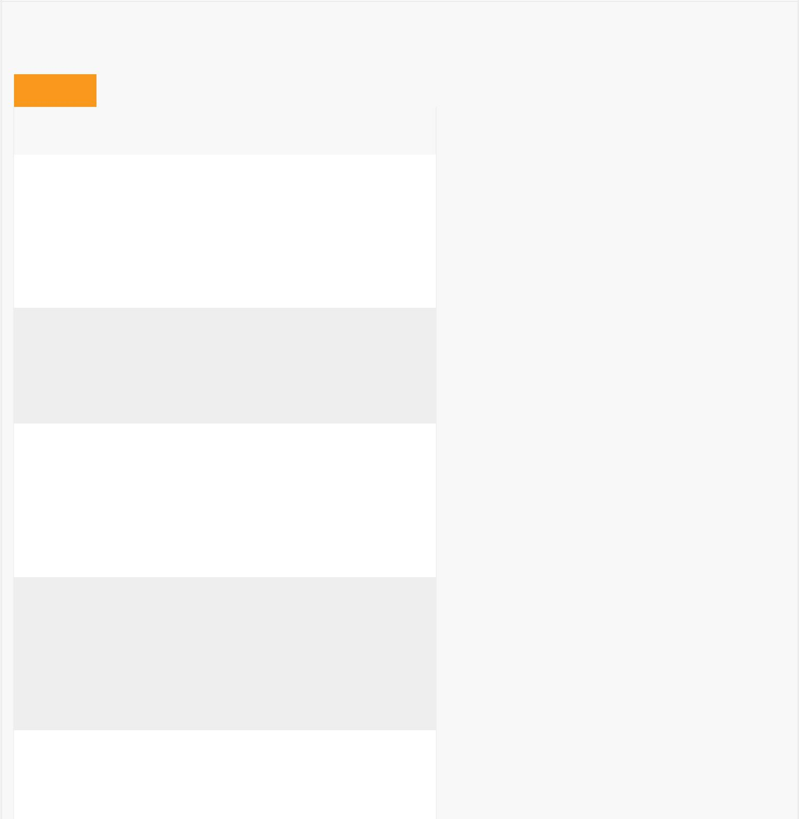

*Field Summary*

Fields

|  |  |
| --- | --- |
| Modifier and Type | Field and |
|  | Description |

private android.widget.TextView breakTextView

Contains the TextView of the break text of the person that is searched

private android.widget.Button button

Contains the Button of the person that is searched

private java.lang.String isFriend

Contains the String of the friend status of the person that is searched

private android.widget.TextView moodView

Contains the TextView of the mood of the person that is searched

private android.widget.TextView nameView

Contains the

TextView of

the name of the person that is searched



Fields inherited from class android.support.v7.widget.RecyclerView.ViewHolder

itemView

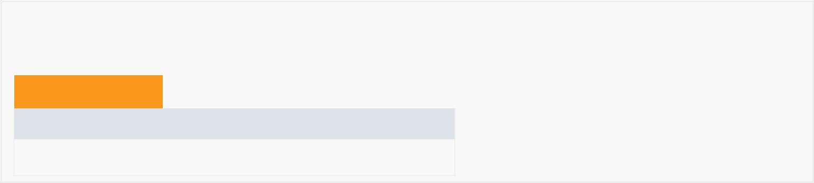

*Constructor Summary*

Constructors

Constructor and Description

MyViewHolderSearch(android.view.View itemView)

|  |  |  |  |  |  |  |  |  |
| --- | --- | --- | --- | --- | --- | --- | --- | --- |
|  | *Method Summary* | | |  |  |  |  |  |
|  |  |  |  | |  |  |  | |
|  | All Methods |  | [Instance Methods](javascript:show(2);) | |  | [Concrete Methods](javascript:show(8);) |  | |
|  | Modifier and Type | |  | Method and Description | | | |  |
|  | void | |  | bind(User person) | | | |  |
|  |  |  |  | Binds the person's name, mood and friend status to | | | |  |
|  |  |  |  | their respective TextView variables. | | | |  |
|  | android.widget.TextView | | | getBreakTextView() | | | |  |
|  |  |  |  | Getter for breakTextView. | | | |  |
|  | android.widget.Button | | | getButton() | |  |  |  |
|  |  |  |  | Getter for button. | | | |  |
|  | java.lang.String | | | getIsFriend() | | | |  |
|  |  |  |  | Getter for isFriendView. | | | |  |
|  | android.widget.TextView | | | getMoodView() | | | |  |
|  |  |  |  | Getter for moodView. | | | |  |
|  | android.widget.TextView | | | getNameView() | | | |  |
|  |  |  |  | Getter for nameView. | | | |  |
|  | void | |  | setBreakText(java.lang.String text) | | | |  |
|  |  |  |  | Setter for breakTextView using a TextView variable. | | | |  |
|  | void | |  | setButton(android.widget.Button button) | | | |  |
|  |  |  |  | Setter for button. | | | |  |
|  | void | |  | setIsFriend(java.lang.String isFriend) | | | |  |
|  |  |  |  | Setter for isFriendView. | | | |  |
|  | void | |  | setMoodView(android.widget.TextView moodView) | | | |  |
|  |  |  |  |  |  |  |  |  |



Setter for moodView.



void setNameView(android.widget.TextView nameView)

Setter for nameView.

Methods inherited from class android.support.v7.widget.RecyclerView.ViewHolder

getAdapterPosition, getItemId, getItemViewType, getLayoutPosition, getOldPosition, getPosition, isRecyclable, setIsRecyclable, toString

Methods inherited from class java.lang.Object

clone, equals, finalize, getClass, hashCode, notify, notifyAll, wait, wait, wait



*Field Detail*

isFriend

private java.lang.String isFriend

Contains the String of the friend status of the person that is searched

nameView

private android.widget.TextView nameView

Contains the TextView of the name of the person that is searched

moodView

private android.widget.TextView moodView

Contains the TextView of the mood of the person that is searched

breakTextView

private android.widget.TextView breakTextView

Contains the TextView of the break text of the person that is searched

button

private android.widget.Button button

Contains the Button of the person that is searched



*Constructor Detail*

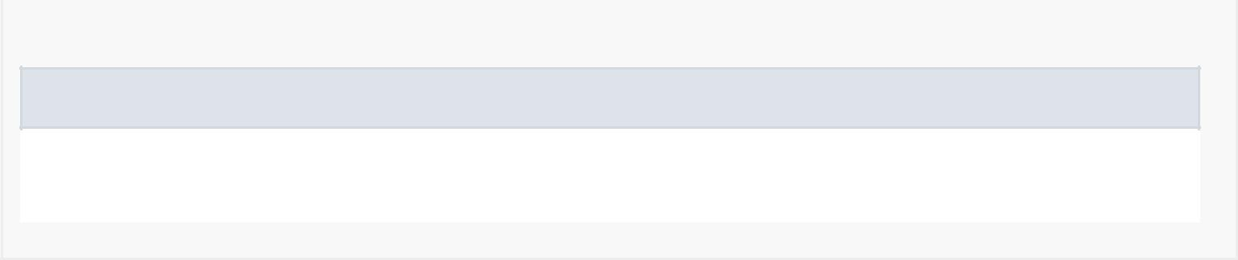

MyViewHolderSearch

public MyViewHolderSearch(android.view.View itemView)



*Method Detail*

bind

public void bind(User person)

Binds the person's name, mood and friend status to their respective TextView variables.

getNameView

public android.widget.TextView getNameView()

Getter for nameView.

setNameView

public void setNameView(android.widget.TextView nameView)

Setter for nameView.

getMoodView

public android.widget.TextView getMoodView()

Getter for moodView.

setMoodView

public void setMoodView(android.widget.TextView moodView)

Setter for moodView.

getBreakTextView

public android.widget.TextView getBreakTextView()

Getter for breakTextView.

setBreakText

public void setBreakText(java.lang.String text)



Setter for breakTextView using a TextView variable.

getIsFriend

public java.lang.String getIsFriend()

Getter for isFriendView.

setIsFriend

public void setIsFriend(java.lang.String isFriend)

Setter for isFriendView.

getButton

public android.widget.Button getButton()

Getter for button.

setButton

public void setButton(android.widget.Button button)

Setter for button.